**Vehicle Collision Detection & Prevention Using VANET Based IoT with V2V**

**Shafin Talukder**†  
 Computer Science & Engineering  
 American International University-Bangladesh   
 Dhaka, Bangladesh  
 [shafintalukder.nill@gmail.com](mailto:shafintalukder.nill@gmail.com)

**Prantika Biswas Sneha**

Computer Science & Engineering  
 American International University-Bangladesh   
 Dhaka, Bangladesh  
 prantika.sneha@gmail.com

**Aseya Khanom**  
Computer Science & Engineering  
 American International University-Bangladesh   
 Dhaka, Bangladesh  
 aseyakhanom99@gmail.com

**Wardah Saleh**  
 Computer Science & Engineering  
 American International University-Bangladesh   
 Dhaka, Bangladesh  
 wardasaleh15@gmail.com

**SK. Tasnim Bari**  
 Computer Science & Engineering  
 American International University-Bangladesh   
 Dhaka, Bangladesh  
 tasnimbariira@gmail.com

ABSTRACT

A change from planned or expected behavior or a sequence of events that endangers or negatively affects people, property, or the environment is defined as an emergency. On the other hand, it can be thought of as a midpoint between collision detection and prevention. This paper presents the results of a major analysis of collision (automobile) emergency alert conditions. In this study, the authors have investigated modern Internet of Things (IoT) and VANET (Vehicular Ad hoc Networks) technologies and developed a collection of modern and specialized techniques, as well as their characteristics. It has sensors that detect unbalanced vehicles and provide a warning to the microcontroller if a collision occurs. The technology has been designed in such a way that it would not only detect but also prevent a collision in any situation. Additionally, the technique can be implemented in such a way that vehicles are alerted of possible closing barriers. Vehicle-to-vehicle communication (V2V) has a huge impact since it allows vehicles to communicate with one another while in close proximity, and the buzzer, together with the LEDs, serves as a safety feature. The system's primary goal is to carry out the microcontroller functions in every environment, moreover the concept refers to detect and prevent the collision in a foggy weather and at night. Wireless technology, along with the Internet of Things (IoT), has resulted in a vast and significant expansion of VANETs infrastructure in recent years (Vehicular Ad hoc Networks). The Internet of Things (IoT) and the Vehicular Ad-Hoc Network (VANET) have now been merged as the fundamental and central components of today's Intelligent Transportation System (ITS). As a result, we'd like to create a system that notifies the driver when a situation is potentially dangerous and quickly shares that area in the event of a collision. If any type of collision occurs, the system will provide emergency assistance such as hospitals, police stations, and insurance companies. A message will be sent to the registered family member's phone number as well. Furthermore, while the procedure of obtaining the insurance may be longer for certain people, others may avoid the law after being involved in severe collisions, making it difficult for authorities to discriminate between criminal and non-criminal evidence.

KEYWORDS

IoT, VANET, collision, sensors, microcontroller, V2V, foggy environment, night-time.

**INTRODUCTION**

Transportation is the act of moving people or products from one location to another in order to suit a user's observed social and economic demands. The transportation system evolves as these needs change, and challenges arise as it becomes harder to serve the public good. Collisions are one of the negative effects of any transportation system [27]. Road accidents adversely impact developing countries on a regular schedule. The main reasons are inadequate infrastructure, traffic control, and accident management. South Asia, particularly India and Bangladesh, have been identified as the developing countries with the highest frequency of accidents [1]. However, given that we have technological superiority on our side and exist in a universe whereby newer technologies are being developed, we can use these approaches in our society to help each other fix issues. Currently, the Internet of Things (IoT) is a figurative concept picturing global Internet connectivity, transforming everyday objects into connected devices. The core idea behind the IoT concept is to spend billions, if not trillions, of smart devices capable of detecting any sort of collisions, general climate, sending and assessing obtained data, and then criticizing the climate. By the end of 2021, it is expected that there will be 28 billion connected devices [6]. IoT systems are a network that connects devices to collect and share data, and they are utilized in a variety of applications [2]. An ad hoc network for automobiles is a network of moving vehicles where each vehicle acts as a node in the creation of a mobile network. Every car or node functions as a wireless router or node, with a communication range of 100 to 300 meters between two vehicles, allowing for a wide range of VANET applications [24].

The advancement of automobiles is quite rapid, resulting in numerous accidents and risks as a result of traffic, foggy weather, night mode and what not. On the other side, the absence of rapid aid, which could have saved a human's life by a few seconds, is the most prevalent cause of death in an accident. It all depends on how swiftly they react, which might be the difference between life and death. [5]. Especially at night and in foggy weather, the ratio of accidents is severe because of the over speed of vehicles and heavy fog. So, it's high time we can apply such strategies related to driving safety for every circumstance in our system and help to manage such challenges because we live in a tech world that is constantly evolving with new technology. It's worth noting that, in recent years, technologies such as IoT and VANET have provided an advanced solution to this problem.

The number of deaths is increasing every week, month, and year. And, if the system continues to move in the same direction, this ratio will never decrease.

It's not just about deaths; there is a slew of additional issues that wreak havoc on the general people. Almost 70% of the population is required to leave home almost every day of the year, either to study or to earn a living [23]. Traffic acts as a barrier in this process, and in the worst-case situation, it produces accidents, which result in deaths. Furthermore, because of the traffic, individuals who have been critically injured cannot be transported to the hospital in a timely manner. Aside from that, driver behavior is the biggest cause of traffic accidents. Though there are a variety of causes for automobile collisions, the majority of them are caused by the driver's inattention and excessive speed. Given the circumstances, it's past time to find a way out of this situation. [18].

In Bangladesh, where an accident victim receives less attention, a device that can communicate with the nearest hospital and police station is required. Each year, more than 3,000 people are killed on Bangladesh's roadways, according to data. With more than 85 deaths per 10,000 registered motor vehicles, the country has one of the world's major causes of death. In most Western countries, this rate is roughly 50 times higher. Furthermore, due to vehicle over-speeding and severe fog, the ratio of accidents is especially high at night and in foggy weather. According to the World Health Organization, road traffic injuries cost Bangladesh roughly 2% of GDP, or £1.2 billion each year (WHO). This is the total amount of foreign aid received throughout the course of a fiscal year. Medical bills, insurance losses, property damage, lost family income, and traffic issues are among the losses. [9].

According to statistics, traffic is one of the most dangerous ways to cause an accident in any situation. Over the last five years, the rate has decreased in the tiniest of ways. Still, there is cause for concern, as the number of deaths relative to the number of accidents is not far apart. The graph below shows the number of individuals who have died in Bangladesh as a result of road traffic accidents in recent years.

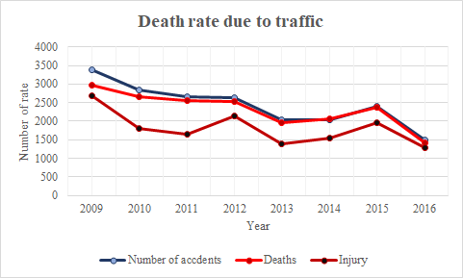

Figure 1: Death rate due to traffic. (Source: Bangladesh Police)

Fog has been an occasional tragedy in our country's recent history, causing fatal accidents. And, shockingly, the death ratio has remained steady in recent years. During the winter season in Bangladesh, the north is blanketed in dense fog. As a result, automobile collisions are fairly common because the driver can barely see what is going on around him. The death rate due to fog during the last ten years is depicted in the graph below.

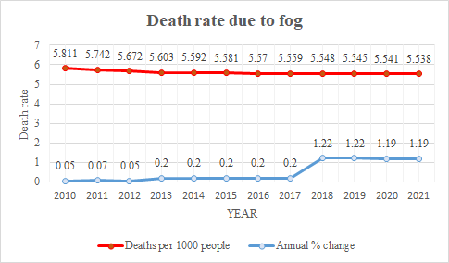

Figure 2: Death rate due to fog. (Source: <https://www.macrotrends.net/countries/BGD>)

**Variety of Accidents**

According to the facts, vehicle crashes are unquestionably one of the most concerning issues for everyone, and they require immediate and decisive action. As previously stated, over speeding, irresponsible behavior, reckless and unsafe driving are the most common causes of automobile collisions. The most common types of car accidents are depicted in the portion below [38].

Rear-end collisions: When a driver suddenly slows down or uses the brakes, this type of collision occurs. The vehicle following the automobile crashed into it from behind as a result of the sudden change in speed, as the driver behind the car did not anticipate the car abruptly applying the brakes.

**Side-impact accidents:** This type of collision occurs when an automobile is struck from the side. Another vehicle could hit the car from the front or rear, or it could be hit by a fixed object.

**Sideswipe collisions:** When two cars driving parallel to each other collide while in motion, this type of collision occurs. When a car collides with a motorcycle, even if it is a minor incident, it can be fatal.

**Vehicle rollover:** A rollover accident occurs when a vehicle crashes with another vehicle or a stationary object. After a collision with something, any vehicle can roll over, although vehicles have a greater portion of rollovers than some other vehicles.

**Head-on collisions:** When two vehicles crash head-on, this is described as a head-on collision. Generally, the outcomes of such an accident are severe and devastating, and the victim's possibilities of survival are tiny.

**Single-car accidents:** When a vehicle meets up with a pole, a wall, or a tree, it is called a single-car accident. A vehicle hitting a person falls into this category and also.

**Multivehicle collision:** Multi-vehicle collisions are most common on congested roads or highways when cars are going at high speeds and in close quarters. Due to the general close vicinity of the vehicles, a significant number of vehicles could crash if one vehicle comes into contact with another. Many innocent persons are harmed in this type of occurrence because of one or two cars.

**Hit-and- run accidents:** A driver impacts someone or an animal and flees in this type of collision.

Accidents are nightmares that strike a specific family in a tragic way, and only that person and their family members appreciate the need for a solution that can provide them with road safety services. With this goal in mind, this project will devise a framework that can identify accidents and notify a hospital, police station, and insurance company, as well as display the nearest hospital to vehicle drivers. As a result, the hospital and police station can mobilize rescue teams in a couple of minutes. In addition, many customers find the procedure of making an insurance claim to be time-consuming. People might sometimes escape the law after being involved in life-threatening accidents, making it difficult for investigators to identify the perpetrators. This program will contribute to addressing all of these issues by reducing the increased loss and damage caused by disasters.

**Literature review**

In paper [9], the authors create a GSM/GPRS/GPS-based car accident detection and rescue information system. It was developing a web service that alerts the owner of the vehicle, the nearest police station, as well as the hospital about the incident and its address. The author concentrated solely on the tracking and rescue aspects, ignoring the alarm component, which is as crucial in preventing a collision. The primary difference between motivation and systems is that they design a system that works after an individual has died, but our system not only performs functions after a collision occurs but also provides an alarm even before the accident occurs. The goal of this project is to create an IoT-based vehicle accident detection and rescue information system that can detect vehicle accidents and relay location information to the vehicle owner, nearby hospital, and police station via a web service. The GSM/GPRS shield is used to establish a connection between the web server and the hardware device, while the GPS shield is used to track the location. Vibration sensors, a keypad, and a buzzer detect the accident. Now, there are some places where our proposed approach is more efficient and beneficial than the existing system. For example, our system first alerts the driver if it detects a possible collision with the help of an ultrasonic sensor and continues to give a series of potential alerts to the driver with the help of LEDs and a buzzer until the collision occurs, and second, it detects any disproportion and then gives an alert to the driver, with the driver having the option of pressing a push-button in both alerts. Our system also has the unique capability of sending collision data to the insurance company for every improvement, which is quite uncommon in any system. Finally, the investigation of V2V communication ensures the highest level of driving safety in every situation.

In paper [36], our proposed solution is advantageous and appropriate in select specific sectors. The authors of this research suggested a framework that may detect accidents following a collision, monitor their location using GPS, and send alarm messages to nearby agencies such as police stations, hospitals, and fire brigades using a GSM module. Our proposed system, on the other hand, provides a method in which the driver is informed before a collision happens using an ultrasonic sensor that measures distance. To alert the driver, four separate LEDs are used, as well as v2v communication with the car. Most importantly, it notifies family members, as well as the police station, hospital, and insurance company. Furthermore, the author wants to explain the vehicle accident detection and rescue system solely. Our proposed system, on the other hand, includes the entire alerting, preventive, and detection processes as well as emergency services and the evaluation of vehicle disproportion.

The proposed IoT-based car accident detection and notification algorithm for general road accidents aim to create a system that allows hospitals and other emergency platforms to receive real-time updates on nearby incidents. That is, an IoT-based framework has been created to keep people up to date on incidents so that emergency medical help may be provided quickly. This can be achieved by utilizing smart sensors with a microprocessor within the vehicle that can be activated in the event of an accident [1].

Smart Car: An IoT-based Accident Detection System, in which a signal from an accelerometer and a GPS sensor is automatically sent to the cloud, where it is received by whoever has subscribed to the car as an alert message. The signal will identify the severity of the collision as well as the GPS location. Then, in order to get to the scene as soon as possible, an ambulance will use the Gps location [11].

This proposed system, the IoT-based Smart Accident Detection & Insurance Claiming System, will identify an accident using a vibration sensor. GPS will be used to determine where you are. The Raspberry Pi sends SMS to a member of the vehicle owner's family through GSM. The cloud server then looks up the contact information for the nearest hospital and police station in the database and informs them of the accident [12].

The main goal of this paper is to detect over-speeding vehicles based on a speed on a speed limit and alert the appropriate individuals using an IoT-based framework. A GPS module, radar, Google maps, and an IoT module are all part of the system. GPS and IoT technology are used to automatically control the safe zones. The battery performance of this activity tracking gadget is between 5 and 10 hours, and the sensor is developed to decrease high accident death rates. It is driven by 12 V lithium batteries and has a GPS sensing network and IoT application; the battery performance of this device is between 5 and 10 hours, and the sensor's purpose is to effectively reduce accident death rates [15].

This study offers a prototype of a smart Black Box System that may be placed into vehicles; based on IoT based Vehicle Accident Analysis, the system attempts to perform accident analysis by objectively tracking what happens within vehicles, as well as improving security by preventing tampering with the Black Box data [28].

Monitoring of Traffic at Night a Robust Framework for Multi-Vehicle Detection, Classification, and Tracking demonstrates how to convert headlamp couples into images of a single vehicle to evaluate other vehicle features such as with the screen or vehicle look. This is a two-stage system to detect with a tracking module that can handle partial and complete objects—the occlusion reasoning technique takes stakes advantage of the headlamp positions as well as the basic traffic scene layout. For scalability and to avoid application-specific cameras, the system's characteristics are generic, so there's no need to change camera settings like low exposure. [30]

IoT Based SMART Helmet for Accident Detection, the main goal of this smart helmet is to keep the rider safe. Additional features such as alcohol detection, accident identification, location monitoring, use as a hands-free device, solar-powered, and fall detection are introduced. This creates not only a smart helmet but also a smart bike feature. The idea aims to ensure the safety and security of bikers on the road. It can be used to make and receive phone calls while driving. Fall detection is a unique feature of the project; if the bike user falls off the bike, it will automatically send a message [44].

Proposed Method

As a third-world country, tragic circumstances such as death from vehicle collisions occur frequently. Vehicle collisions are less prevalent in developed countries, and one of the primary reasons for this is population density. We must be concerned about any sort of vehicle collisions because our country is overcrowded and has no plans to lower its population in the near future. The concern is especially concerning foggy weather and a lack of light at night according to the statistics of our country. As a result, we'd like to develop a system that alerts people when a scenario is potentially harmful and quickly shares that area in the event of an accident. In order to achieve this goal, we created a VANET based IoT vehicle accident detection and rescue data platform that uses GPS and GSM to recognize vehicle wrecks and communicate location data to vehicle owners, adjacent emergency hospitals, police stations, and an alert message is sent to the registered family members. On the other hand, VTS (Vehicle Tracking System) performs the same functions as radar, such as nearest rescue platforms checks and vehicle tracking, and as a result, certain VTS can identify accidents. Unlike most other systems, this proposal also discusses the concept of reporting collisions to the insurance company's headquarters in order to acquire a report of all documents linked with that specific vehicle. Police officers have a tough time identifying culprits because people can flee the scene of a life-threatening accident.

Communication verification:

The collision avoidance system employs V2X communication. The three types of V2X communication are vehicle-to-vehicle (V2V) and vehicle-to-infrastructure (V2I). The vehicle can communicate with the other vehicles, infrastructure, and people using this communication system. [6]

**VANET (Vehicular ad hoc networks)**

VANET is an acronym for "vehicular ad-hoc network." It increases both the comfort and the safety of driving. The scope of the VANET application has grown as a result of recent technology breakthroughs and the emergence of smart cities around the world. VANET is a self-aware technology that aids in the improvement of traffic services and the reduction of road accidents. Because the information given by this system is time-sensitive, it is essential that dependable and fast network connections be established [13]. Although VANET, as a wireless ad hoc network, flawlessly achieves this purpose, it is subject to security concerns. Attackers are attracted to this network because of its extremely dynamic connections, sensitive data sharing, and timing sensitivity [13]. Approximately 80% of accidents lead to the demise of multiple people. Road accidents adversely impact developing countries on a regular schedule. The main reasons are inadequate infrastructure, traffic control, and accident management. Because spontaneous networking is the main concern of VANET, facilities such as RSUs or cellular networks are less of a problem.

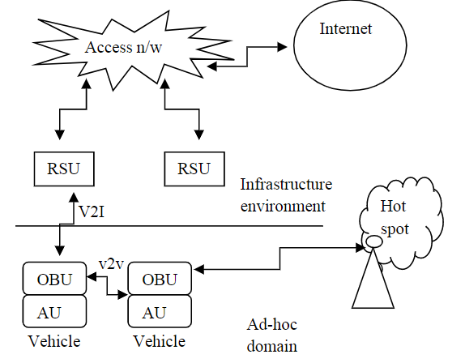

Figure 3: Architecture of VANET [14]

**Application of VANET:**

The applications of VANET have now spread in a number of categories where the main motive is to ensure safety in different circumstances. Some of the VANET applications are vehicle collision warning, security distance warning, driver assistance, cooperative driving, internet access, map location, automatic parking, driverless vehicle etc.

**Fields of VANET** Though our motive is to reduce collisions, there has been a significant number of fields of VANETs which have taken wireless technology into the modern era. Some of the fields of VANET are Intersection collision warning, Lane change assistance, Road map, Accident detection and alerting, Traffic planning, Overtaking vehicle warning, Emergency vehicle warning, Point of interest (PoI) allocation, Weather information.

**VANET challenges:**

Past study has largely noted the potential of increasing the number of attached devices in the system, energy utilization, unstable traffic flow, geographic conditions, unexpected network connectivity, and transmission storm. [8]. First, VANET disseminates sensitive data, attracting a wide range of opponents.[9] Second, the WAVE standard does not include any authentication or association protocols because of the need for quick network deployment.[9] Third, the model is easier to attack because of a lack of infrastructure.[9] Fourth, there's a good chance your privacy will be compromised.[9] Lastly, connection infiltration is relatively simple due to the continually changing topology.[9]

**VTS (Vehicle Tracking System)**

Bangladesh has access to this VTS. Vehicle Tracking System (VTS) is provided by a number of companies, including GP and ROBI, and provides some standard services such as vehicle tracking via satellite GPS and GSM connection. Therefore, no system is available that can both identify as well as provide VTS. Each VTS fulfills the same functions, including speed checks and traffic monitoring. Accident detection can be done with some VTS. In the event of an accident, however, there is no VTS that notifies the nearest hospital and police station. This system measures distance and tracks imbalance situations by different sensors, which give us distance alerts. By using V2V communication, the drivers could be aware of any kind of dangerous incidents. If there is an accident, it can notify with GPS and GSM and automatically send alert messages to registered numbers. Servers search nearby hospitals, police stations, and insurance company phone numbers from the database and notify them for urgent help to reduce instant loss or damage.

**System architecture**

**List of component and technology**

Based on a thorough evaluation of the papers and a step-by-step review of the results, the components and technologies that has chosen are Ultrasonic Sensor, Vibration Sensor/ Accelerometer, LED, Buzzer, GPS, GSM, Push Button, Wi-Fi Module, Cloud Server and Arduino**.**

**Graphical architecture based on requirement tool**

To address the scarcity of publicly available standard datasets for collision detection and prevention, we suggest an IoT-based accident detection and prevention system. The system architecture is depicted. Most cars now feature built-in GPS devices to assist passengers while driving. This segment has been prepared to come up with the based ideation of the system. The portion will basically make understand of each and every connection of every component with each other. The downscaled figure introduces the overall architecture of the system:

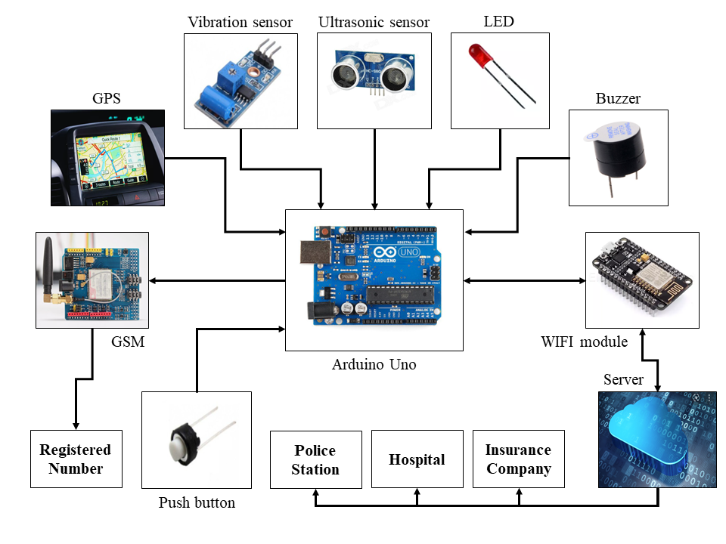

Figure 4: Graphical architecture

**Description of the connections of the architecture**

We propose an IoT-based accident detection and prevention system in order to address the shortage of readily available standard datasets for collision detection and prevention. Figure 4.3 displays the system architecture. Most automobiles now have built-in GPS systems to aid passengers while driving.

The vibration sensor and the ultrasonic sensor are both active at the same time in this situation. Through the use of ultrasonic sound waves, an ultrasonic sensor is used to estimate the distance between vehicles. The ultrasonic sensor in our system is linked to an Arduino Uno microcontroller. It is used to notify drivers of their vehicle's location, and the system will notify them via red, green, yellow, and blue LEDs and the red LED alert accompanied by a buzzer sound. The point to be noted is that the LEDs are connected with the microcontroller. Through vehicle-to-vehicle communication, an alert message will be delivered to all vehicles within a certain range.

The vibration sensor is used to detect the unbalanced situation and is connected to the Arduino Uno. When the vibration value exceeds the threshold limit, the vibration sensor detects a mishap and alerts the Arduino-Uno. The Arduino-Uno is controlled by a single push button switch. If the button is pressed within 30 seconds, the system considers the driver to be safe and does not advance to the following phase. However, if it is not pressed within that period, the system will advance to the next phase because the driver is not in excellent shape.

The data is subsequently sent via the processor's Wi-Fi module to the cloud server. The microcontroller is linked to the Wi-Fi module in our suggested system. Furthermore, the Wi-Fi module is connected to the cloud server.

Simultaneously, the system sends SMS to the registered number using the GSM module. The Arduino-Uno is connected to the GSM module in our system. The cloud server scans the database for phone numbers for the nearest hospitals, police stations, and insurance companies, as well as any new accident information. As a result, the hospital will dispatch an ambulance to the accident scene, along with a police officer to document the crime scene. The circumstances of the collisions will also be given to the insurance companies so that a representative can attend on the spot and speed the insurance claim procedure.

**Flow chart**

In this segment, a flowchart encompassing all of the specifications and work instructions is demonstrated. Some functions respond differently when it comes of the system's responses, and those functions are defined accordingly.

Because the flowchart contains a number of features as instructed, here is a summery overview of 3 of the features we have focused in our system which the flow chart overall is showcasing.

**Distance measuring through an ultrasonic sensor:** The system looks at a sensor that can measure distance and then provide step-by-step warning to the driver.

**Disproportionate detection through a vibration sensor**: Contains a sensor that will react to any disproportionate occurrence. There is an alert mechanism in this mode that notifies the driver of the disproportion.

**Functions of work design of sending notifications to certain platforms:** Contains the platforms that will be notified of the vehicle's status. Each platform, on the other hand, has its own purpose for being notified. And as we've been through the papers and journals over the months, we've discovered that these are the most important platforms that should work together to respond to a collision.

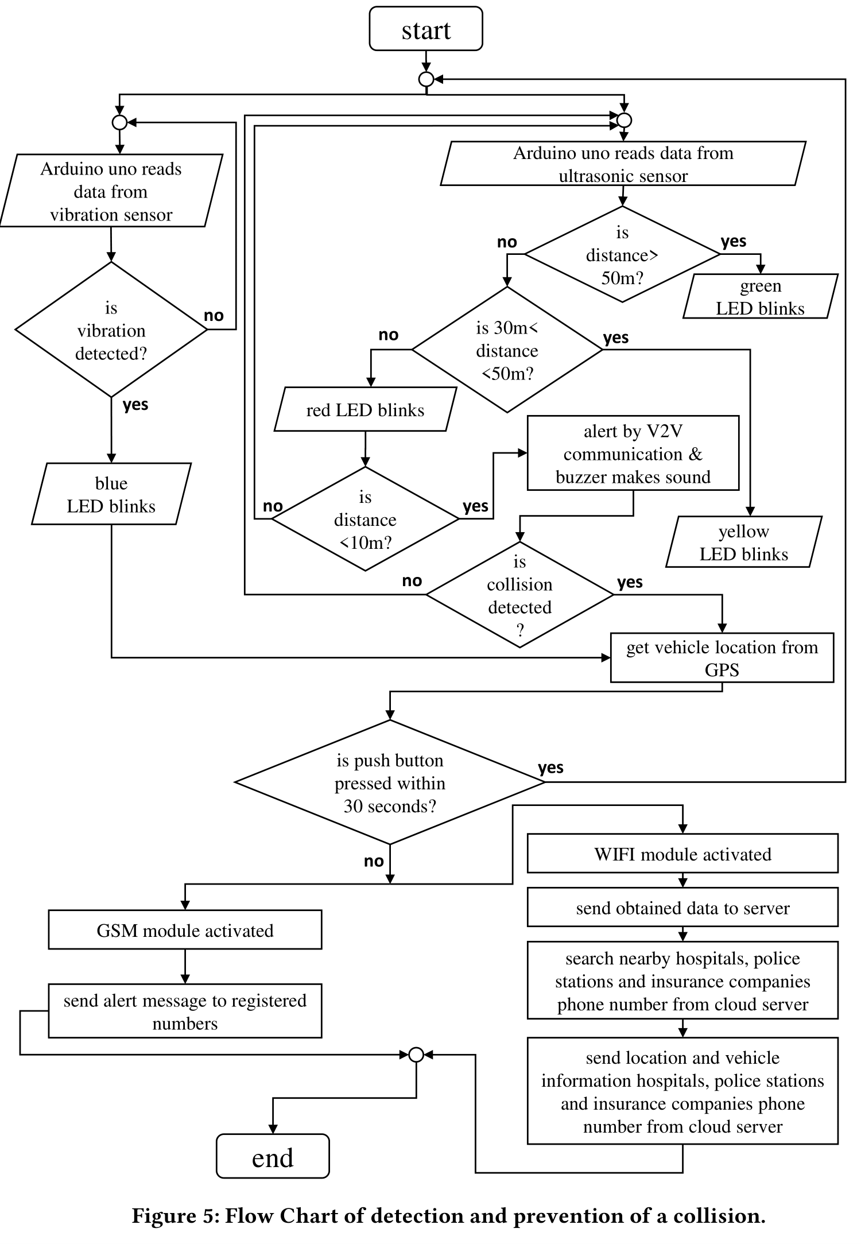Here is the summation of the entire system. The microprocessor begins its functions as soon as the vehicle starts up. Two sensors are used in the system: an ultrasonic sensor and a vibration sensor. In such situations, both sensors have their own set of needs. In addition, both sensors will begin working at the same time and carry out their functions.

After the Arduino reads data from the ultrasonic sensor, the system will measure the distance between vehicles or obstacles around it every second. If there is no vehicle within 50 meters of the system, a green LED blinks continuously; nevertheless, if something enters that range, the system begins flashing with a yellow LED. The yellow LED will continue to flash until the distance is between 30 to 50 meters, and if the range is less than 30 meters, a red LED will begin blinking.

If a vehicle appears within 10 meters, the system sends a warning message via V2V communication with a buzzer making noise all along to confirm the probability of a collision. If this is not the case, the system will resume processing from the beginning.

Following that, if a collision occurs, the sensor will confirm the collision, and the GPS will follow the vehicle's location immediately. There is also a push-button function in the system that the driver can use. The system does not send any alarm messages if the driver presses that button. However, if the button is not pressed within a specific length of time, the system will proceed to the next step.

If the push button is not pressed, the GSM and WIFI modules are activated at the same time. The WIFI module delivers the data to the server, GSM, on the other hand, delivers the alert message together with the necessary information to the registered phone numbers. Following the transmission of the gathered data, the WIFI module looks for the phone numbers of nearby hospitals, police stations, and insurance organizations. If the server discovers any contact numbers, it transmits the collision information to that contact right away. On the other hand, the vibration sensor checks for any disproportionate condition and, if it detects one, the system blinks a blue LED to inform the driver of the problem. If the driver presses the push button, the process begins again, but if the button is not pressed, GPS will monitor the location, and the GSM and WIFI modules will execute their functions as before.

**Case Diagram**

The following showcases the case diagram of the system. The case diagram helps to understand the connectivity’s between the actors and the actions. The following one represents the relations between the user and the system of our proposed system.

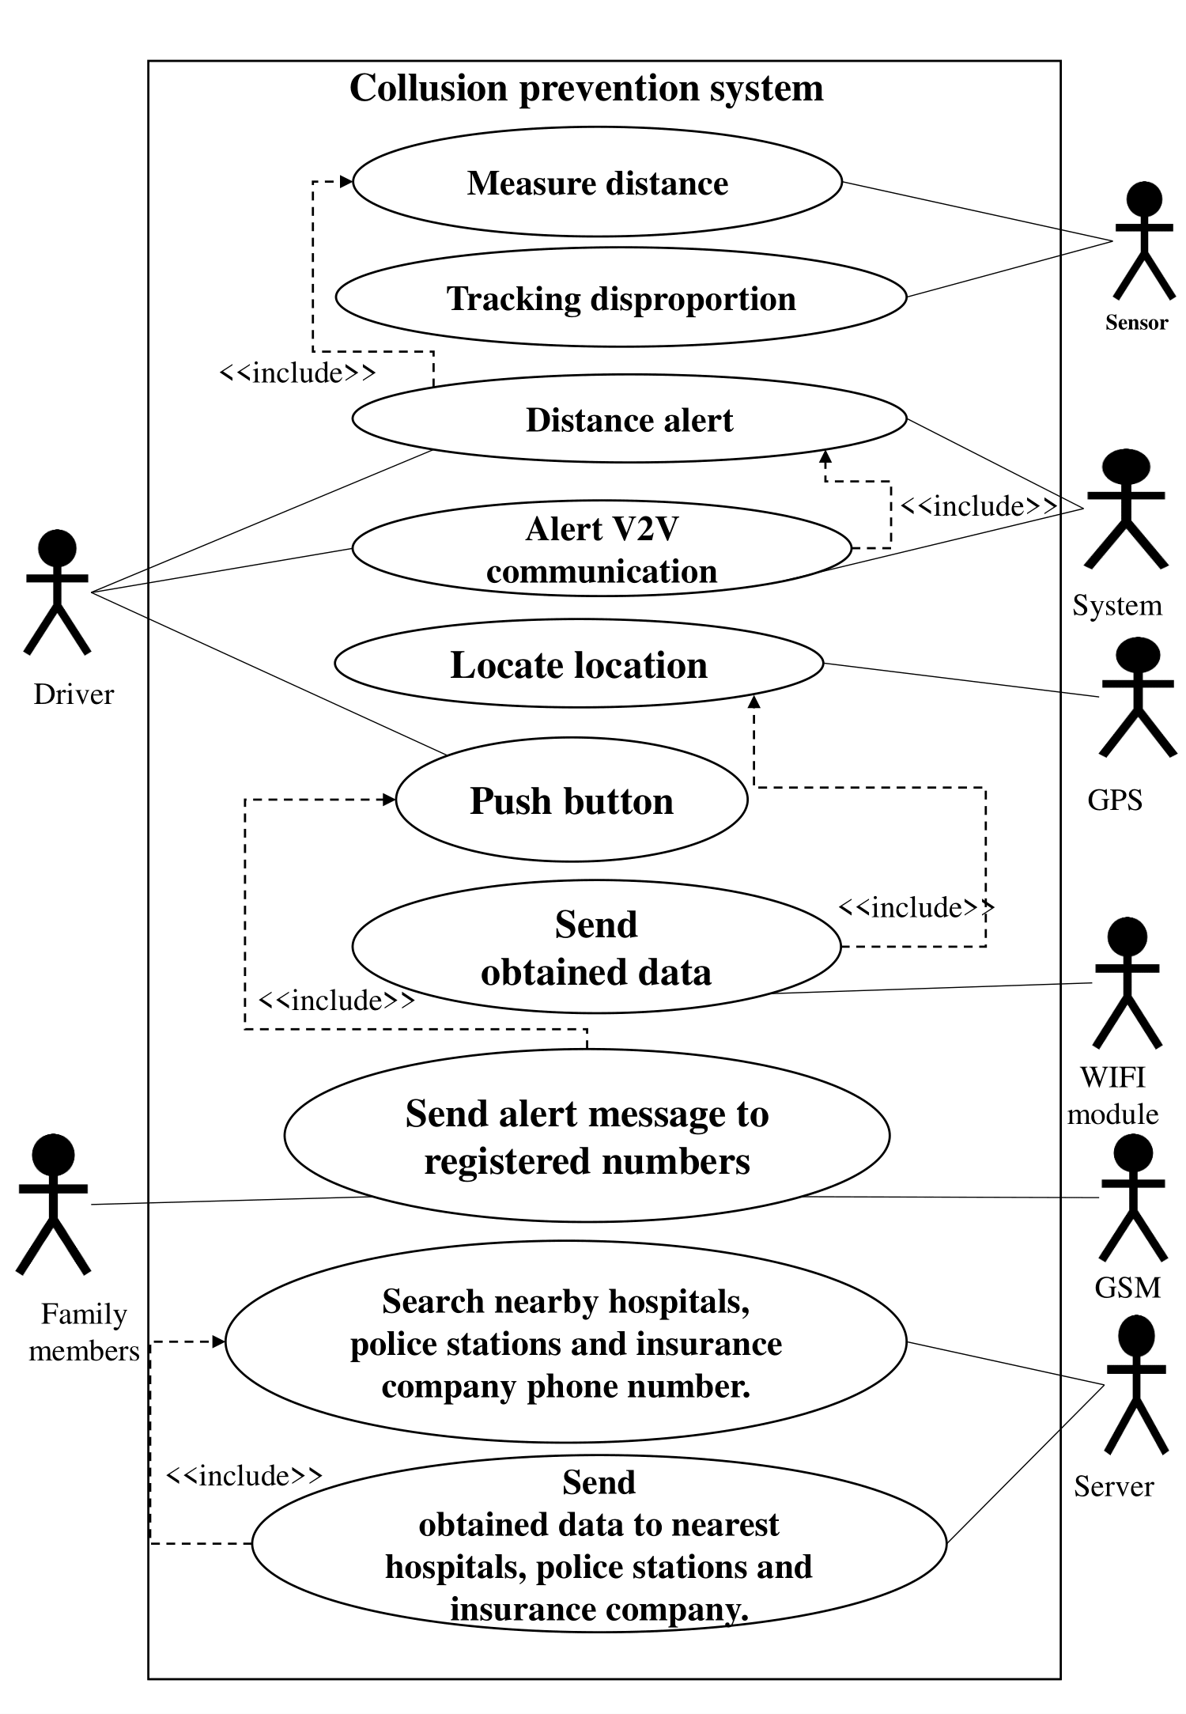

**Figure 6: Case diagram of detection and prevention**

**Table of contents of the case diagram**

The downscaled table will showcase the functionalities of each actor and the actions of the case diagram.

**Table 1 : The contents of the case diagram**

|  |  |  |
| --- | --- | --- |
| **Actors** | **Condition** | **Function** |
| Driver | 1. The vehicle owner or drive the vehicle.  2.Drivers should have a driving license. | 1.Distance alert.  2.Alert by V2V communication.  3.Push-button. |
| Sensor | 1.Must be installed in the system. | 1.Measure the distance  2.Tracking disproportion. |
| System | 1.Must be installed in the vehicle | 1.Distance alert  2.Alert V2V communication |
| GPS | 1.Must be installed in the system. | 1.Locate the location |
| GSM | 1.Must be installed in the system. | 1.Send an alert message to registered members |
| WIFI Module | 1.The system's input and output are supplied by an external system. | 1.Send obtained data |
| Server | 1.System required information is supplied by the Wi-Fi module. | 1.Send obtained data to nearest hospitals, police stations, and insurance companies. |
| Family Member | 1.The number must be registered on the server. | 1.Send alert messages to registered members |

**Comparison Table of related work**

The table showcase different types of solutions from previous related works:

**Table 2: Comparison Table**

|  |  |  |  |  |  |  |  |
| --- | --- | --- | --- | --- | --- | --- | --- |
| Title reff | Location detection | Alert messages | Alert based on distance | Family member | Police station | Hospital | Insurance Company |
| [12] | ✓ |  |  | ✓ | ✓ | ✓ | ✓ |
| [29] | ✓ |  |  |  | ✓ | ✓ |  |
| [17] |  | ✓ | ✓ |  |  |  |  |
| [08] | ✓ |  | ✓ | ✓ |  |  |  |
| [11] | ✓ |  |  | ✓ |  | ✓ |  |
| [37] | ✓ | ✓ |  | ✓ |  | ✓ |  |
| [02] | ✓ | ✓ |  |  |  | ✓ |  |
| [34] | ✓ | ✓ |  |  |  | ✓ |  |
| [14] | ✓ |  | ✓ | ✓ | ✓ | ✓ |  |
| [36] | ✓ | ✓ |  | ✓ |  | ✓ |  |
| Our System | ✓ | ✓ | ✓ | ✓ | ✓ | ✓ | ✓ |

**Estimated cost**

This segment has presented the estimated cost of our system. As you can see, the whole cost of the entire proposal is only near to 2000 which is quite affordable.

**Table 3: Table of the estimated cost**

|  |  |  |  |
| --- | --- | --- | --- |
| Components | Quantity | Estimate Price (BDT) | Estimate Price  (Dollar $) |
| Ultrasonic sensor | 2 | 200 | 2.33 |
| Accelerometer | 1 | 279 | 3.25 |
| LED | 4 | 16 | 0.19 |
| Buzzer | 1 | 15 | 0.18 |
| Push Button switch | 2 | 10 | 0.12 |
| Arduino Uno | 1 | 609 | 7.16 |
| Wi-Fi module | 1 | 410 | 4.82 |
| GSM Module | 1 | 403 | 4.74 |
|  | **Total Price** | **1942** | **22.64** |

Security of the system

The system's overall security is a critical component. Securing wireless communication between devices isn't a major concern. There are a variety of mechanisms for secure position verification, authentication, data security, obscurity, and security in ad-hoc wireless networks and the VANET itself. [26].

There are essential parts that must be secured for the tracking part. GPS must be secured from two kinds of attacks: removing or changing the facts of its memory and being unplugged or switched off from the vehicle. [26] The first assault can be solved easily by using data security prevention and fault-tolerant industrial design. Furthermore, no one can update or modify the onboard unit's internal database since there are no input ports. The traffic administration or automobile manufacturers are entirely responsible for vehicle identity connection [26]

**Effective chart of solutions proposed for the prevention of road accident**

This graph demonstrates the effectiveness chart, which shows exactly our system's efficacy position. The efficacy of sending alert message is unsatisfying and came at the expense of outcomes. The police station is effective in this sector; however, it falls short of the required. Notifying family members of an accident is critical. Though it falls short of perfection. The insurance company's efficacy rate is lower than that of any other factor.  The hospital has a revolutionary rate of efficacy, which enhances it to the top of our ranking. Two critical factors are accident site detection and distance measurement alerts. Between them, the rate of accident site detection is sufficient, but the rate of distance measurement alerts is not satisfactory. If we assess on the basis of each experimental basis, our system will achieve the highest percentages.

**Discussion**

The proposal has been developed with the influence of rapid and advanced technology of VANET and IoT in vehicle-related systems. Unlike other proposals, as our system can work out in different circumstances and additionally the installation of the system is very convenient and easy to understand and use, this will encourage vehicle owners and also the companies to experience the use of it. The use of two different sensors has given the result of the maximum level of driving safety. And also, the technology of V2V can introduce an upper level of technology in Bangladesh. In addition to that, the system is also very interactive as it interacts with the driver with LEDs. The latest part of VTS can also encourage a certain number of platforms to develop different fields of security, and it also takes our technology to an advanced platform. Last but not least, the system has introduced an advanced use of those components which already exist in cars in our country, for example, GPS.

**Future work plans**

**Animal detection:** In our system, there is no animal detecting functionality. However, having these features in a system is

critical since animals frequently move in the center of the road or attempt to cross it, particularly in the Bandarban and Chittagong

areas, where animals frequently visit the road at night. Large animals have the potential to kill, injure, or damage humans and their property.

**Doesn’t work in every circumstance:** Vehicle design, speed of operation, road layout, weather, road conditions, driving abilities, and impairment caused by alcohol or drugs are all factors to consider., and conduct, particularly aggressive driving, distracted

driving, speeding, and street racing, all contribute to the probability of crashes. Any type of traffic collision necessitates these characteristics. However, because VANET does not work in the rain, all of the above elements will not work in every situation. As a result, there is still the slightest possibility of a safety problem. However, our system is one of the options for detecting a vehicle accident when compared to the other features.

**Time Consuming:** VANET is a self-aware technology that has a major impact on traffic service improvement and lowering road accidents. Because the information communicated in this system is time-critical, it necessitates the construction of reliable and fast network connections. VANET, as a wireless ad hoc network, fulfills this requirement perfectly; however, it is vulnerable to security assaults. This network's highly dynamic connections, sensitive information sharing, and timing sensitivity make it an appealing target for attackers.[14]

**Drowsy Driver Detection:** Our system can't detect drowsy drivers. And also, we didn't use alcohol sensors to detect alcoholic drivers in our system. As previously said, our system would warn the driver with various blinking LEDs and buzzers based on the distance to avoid a collision. In case any driver feels asleep, then this system will help him at least a little bit from the collision.

**Animal detection:** In Chittagong, tourist destinations include Bandarban, Kaptai, and a few other interesting places; animals do occasionally visit the road at night. Tree snakes, striped keelbacks, and dead water snakes were among the snakes thrown on the road by some boys. These occurrences are fairly typical during long-distance journeys in Bangladesh for various purposes. As a result, a mechanism is required to prevent any accidents as a result of this.

**Drunk Driver Alert System (particularly in highway bus cases):** Accidents frequently occur as a result of a lack of awareness. Particularly dangerous crashes occur when truck and bus drivers are drunk late at night. A future scope can be added to the suggested system to avoid this issue. Even before an accident occurs, sensors will detect that the driver is drunk, and data will be sent to the nearest police station by GPS and GSM. In addition, a sensor to detect eye blinks and a Raspberry Pi camera to assist in image capturing can be added [34].

**Reckless Driving:** One of the leading causes of traffic accidents has been identified as blindfold driving. In truth, the majority of accidents on our roads are caused by inexperienced drivers hurried and careless driving. Due to a lack of traffic restrictions and the impunity enjoyed by drivers said to be a frequent practice in our country. In many ways, the two elements mentioned above, a lack of enforcement of the law and impunity, motivate irresponsible driving. Another obvious factor is the issuance of driver's licenses without following the proper procedures.

**Driving License:** A huge majority of drivers are uninformed of the traffic rules and regulations that apply to their driver's license. If the person has a driver's license, it should be checked to see if it is valid. The RFID technique can be used to avoid this problem. The RFID reader on the car will have a maximum of 10 registered users who will be able to utilize it. As a result, this helps to ensure that the vehicle is not stolen and that the person riding it is not under the age of 18 or inexperienced [21].

**Conclusion**

VANET and IoT are rapidly evolving technologies that have been effectively implemented in vehicle-related systems. Our proposed system has been explored with the help of advanced technology. Undeniably, our provided solution has many advantages compared to previous solutions. Based on a particular distance, two types of vehicles & objects are detected via sensors. The technology will assure the driver's safety by utilizing several types of LEDs. Additionally, the safety of nearby vehicles is being ensured through V2V communication. If a collision has occurred, then without any delay, this system provides emergency help as soon as possible. Besides, it can keep monitoring the present state of the vehicle with the help of GPS. Compared to other systems, our proposed approach consists of low cost. Despite the fact that the suggested system has been designed to be simple, easy to use, and flexible, various known problems remain.

ACKNOWLEDGMENTS

Firstly, we want to express our gratitude to Allah for providing us with the strength, patience, and expertise necessary to complete this project. The research team are eternally thankful to the Department of Computer Science and Engineering at the American International University of Bangladesh for authorizing them to conduct this research. Our supervisor, Warda Saleh mam, has been supportive and helpful in providing us with continuing suggestions as well as crucial information and the approach to our project. We may not get such a hard-working supervisor for this project. Lastly, we are grateful to our team members for working hard.

REFERENCES

1. Sharma, S. and Sebastian, S., 2019. IoT based car accident detection and notification algorithm for general road accidents. *International Journal of Electrical and Computer Engineering (IJECE)*, [online] Vol.9(No.5), p.7. [Accessed 17 December 2021].
2. Nagvekar, A., Betkar, S., Kute, V. and Patil, A., 2021. SIMULATION OF ACCIDENT DETECTION SYSTEM USING VANET. *www.ijrar.org* (E-ISSN 2348-1269, P- ISSN 2349-5138), 7(1), p.4.
3. K. Ashokkumar, C. Venkata Deepak and D. Chowdary, "Sign Board Monitoring and Vehicle Accident Detection System Using IoT*," International Conference on Frontiers in Materials and Smart System Technologies*, 2021. Available: 10.1088/1757-899X/590/1/012015 [Accessed 10 October 2021].
4. H. Singh, K. Tiwari, P. Pandey, and R. Maheshwari, "IOT Based Automatic Vehicle Accident Detection and Rescue System," *International Research Journal of Engineering and Technology (IRJET)*, vol. 7, no. 4, p. 5, 2020. Available: http://www.irjet.net. [Accessed April 2020].
5. P. Prakash, P. Kalyan V, M. Kumar D A, J. Reddy, and P. G S, "VEHICLE COLLISION DETECTION USING IOT," *International Research Journal of Modernization in Engineering Technology and Science*, vol. 2, no. 5, p. 9, 2021. Available: http://www.irjmets.com. [Accessed May 2020].
6. Hatim, S., Elias, S., Awang, N. and Yusof Darus, M., 2018. VANETs and Internet of Things (IoT): A Discussion. *Indonesian Journal of Electrical Engineering and Computer Science*, Vol.12(No.1), p.8.
7. Elsagheer Mohamed, S., 2013. Smart Street Lighting Control and Monitoring System for Electrical Power Saving by Using VANET. *Int. J. Communications, NetworkandSystemSciences*, [online] 6(351-360), p.10.
8. S., Srimanikandan, S., Sriram, G. and Jenifer, A., 2020. Automatic Accident Detection and Reporting System. *IJESC,*, [online] Volume 10(Issue No.8), p.4.
9. SANY, S. and RIYADH, M., 2017. IoT Based Vehicle Accident Detection & Rescue Information System. [online] *Dspace.ewubd.edu*
10. S. Vargheese, J. Varghese and S. T.G, "NIGHT TIME ACCIDENT DETECTION AND TRAFFIC SURVEILLANCE SYSTEM," JAC: A JOURNAL OF COMPOSITION THEORY, vol. 13, no. 3, p. 12, 2021. Available: ISSN : 0731-6755 [Accessed March 2020].
11. Shaik, A., Bowen, N., Bole, J., Kunzi, G., Bruce, D., Abdelgawad, A. and Yelamarthi, K., 2019. Smart Car: An IoT Based Accident Detection System. *2018 IEEE Global Conference on Internet of Things (GCIoT)*, [online] p.4. Available at: <https://ieeexplore.ieee.org/abstract/document/8620131> [Accessed 17 December 2021].
12. K. L. Narayanan, C. R. S. Ram, M. Subramanian, R. S. Krishnan, and Y. H. Robinson, "IoT based Smart Accident Detection & Insurance Claiming System," 2021 Third International Conference on Intelligent Communication Technologies and Virtual Mobile Networks (ICICV), 2021, pp. 306-311, DOI: 10.1109/ICICV50876.2021.9388430.
13. S.R, A., Rai, A., M.A, P. and S.C, S., 2015. An IoT Based Accident Prevention & Tracking System for Night Drivers. *International Journal of Innovative Research in Computer and Communication Engineering*, [online] Vol. 3(Issue 4), p.7. Available at: [Accessed 17 December 2021].
14. Chourasia, P., Choubey, S. and Verma, R., 2020. Vehicle Accident Detection, Prevention and Tracking System. *International Research Journal of Engineering and Technology (IRJET)*, [online] Volume: 07(Issue: 08), p.7. [Accessed 17 December 2021].
15. Khan, M. A., & Khan, S. F. (2018). IoT-based framework for Vehicle Over-speed detection. 2018 1st International Conference on Computer Applications & Information Security (ICCAIS). doi:10.1109/cais.2018.8441951
16. Nanda, S., Joshi, H., & Khairnar, S. (2018). An IoT Based Smart System for Accident Prevention and Detection. 2018 Fourth International Conference on Computing Communication Control and Automation (ICCUBEA). doi:10.1109/iccubea.2018.8697663
17. Amin, A. B., Patel, H. P., Vaghela, S. P., & Patel, R. R. (2019). IoT Based Vehicle Anti-Collision And Pollution Control System. 2019 3rd International Conference on Electronics, Communication and Aerospace Technology (ICECA). doi:10.1109/iceca.2019.8822059
18. Anadu, D., Mushagalusa, C., Alsbou, N., & Abuabed, A. S. A. (2018). Internet of Things: Vehicle collision detection and avoidance in a VANET environment. 2018 IEEE International Instrumentation and Measurement Technology Conference (I2MTC). doi:10.1109/i2mtc.2018.8409861
19. Patel, N. S., & Singh, S. (2016). A survey on techniques for collision prevention in VANET. 2016 International Conference on Wireless Communications, Signal Processing and Networking (WiSPNET). doi:10.1109/wispnet.2016.7566422

[20] Yaswanth, P., Ram Kumar, N., MukeshKumar, R. and Singh, K., 2019. Automatic Traffic Violation Recording and Reporting System to Limit Traffic Accidents: Based on Vehicular Ad-hoc Networks (VANET). *2019 International Conference on Innovative Trends in Computer Engineering (ITCE)*, [online] p.11. [Accessed 17 December 2021].)

1. Elsagheer Mohamed, S. A. (2019). Automatic Traffic Violation Recording and Reporting System to Limit Traffic Accidents: Based on Vehicular Ad-hoc Networks (VANET). 2019 International Conference on Innovative Trends in Computer Engineering (ITCE). doi:10.1109/itce.2019.864644
2. Jayapal, C., & Roy, S. S. (2016). Road traffic congestion management using VANET. 2016 International Conference on Advances in Human-Machine Interaction (HMI). doi:10.1109/hmi.2016.7449188
3. Thangammal, B., Ilamathi, K., Santhoshini, P., Lahari, V.S., Samyuktha, S., and Vineela, S., 2021. IoT-based Vehicle Accident Analysis. Annals of the Romanian Society for Cell Biology, pp.17861-17866
4. R. Rishi, S. Yede, K. Kunal, and N. V. Bansode, "Automatic Messaging System for Vehicle Tracking and Accident Detection," 2020 International Conference on Electronics and Sustainable Communication Systems (ICESC), 2020, pp. 831-834, DOI: 10.1109/ICESC48915.2020.9155836.
5. K. Robert, "Night-Time Traffic Surveillance: A Robust Framework for Multi-vehicle Detection, Classification and Tracking," 2009 Sixth IEEE International Conference on Advanced Video and Signal Based Surveillance, 2009, pp. 1-6, doi: 10.1109/AVSS.2009.98.
6. B. Fernandes, V. Gomes, J. Ferreira, and A. Oliveira, "Mobile Application for Automatic Accident Detection and Multimodal Alert," 2015 IEEE 81st Vehicular Technology Conference (VTC Spring), 2015, pp. 1-5, DOI: 10.1109/VTCSpring.2015.7145935.
7. N. Amin and M. Borschbach, "Quality of obstacle distance measurement using Ultrasonic sensor and precision of two Computer Vision-based obstacle detection approaches," 2015 International Conference on Smart Sensors and Systems (IC-SSS), 2015, pp. 1-6, DOI: 10.1109/SMARTSENS.2015.7873595.
8. Xue Yang, Jie Liu, Feng Zhao, & Vaidya, N. H. (n.d.). A vehicle-to-vehicle communication protocol for cooperative collision warning. The First Annual International Conference on Mobile and Ubiquitous Systems: Networking and Services, 2004. MOBIQUITOUS 2004. doi:10.1109/mobiq.2004.1331717
9. A Kaur, M., Malhotra, J. and Deep Kaur, P., 2020. A VANET-IoT based Accident Detection and Management System for the Emergency Rescue Services in a Smart City. *Infocom Technologies and Optimization (Trends and Future Directions) (ICRITO)*, p.968.
10. P. Yaswanth, N. Kumar, R. Kumar, and K. Singh, "Smart Assistant for Accident Prevention and Rescue," Capstone, p. 11, 2021. Available: *https://scholar.archive.org*. [Accessed 1 December 2020].
11. MATTHEWS, V. and ADETIBA, E., 2011. Vehicle Accident Alert and Locator (VAAL). International Journal of Electrical & Computer Sciences IJECS-IJENS, [online] 11(02). Available at: <[http://eprints.covenantuniversity.edu.ng/1663/#.YSpLxY4zbIX>](http://eprints.covenantuniversity.edu.ng/1663/#.YSpLxY4zbIX%3E) [Accessed 6 April 2011].
12. Chourasia, P., Choubey, S. and Verma, R., 2020. Vehicle Accident Detection, Prevention and Tracking System. International Research Journal of Engineering and Technology (IRJET), [online] Volume: 07(Issue: 08), p.7. [Accessed 17 December 2021].
13. G. Samara, W. A. H. Al-Salihy and R. Sures, "Security Analysis of Vehicular Ad Hoc Networks (VANET)," 2010 Second International Conference on Network Applications, Protocols and Services, 2010, pp. 55-60, DOI: 10.1109/NETAPPS.2010.17.
14. B. A. Valli and P. Jonnala, "Vehicle positioning system with accident detection using accelerometer sensor and Android technology," 2017 IEEE Technological Innovations in ICT for Agriculture and Rural Development (TIAR), 2017, pp. 73-77, DOI: 10.1109/TIAR.2017.8273689.
15. N. Kattukkaran, A. George and T. P. M. Haridas, "Intelligent accident detection and alert system for emergency medical assistance," 2017 International Conference on Computer Communication and Informatics (ICCCI), 2017, pp. 1-6, DOI: 10.1109/ICCCI.2017.8117791.
16. Elsagheer Mohamed, S. A. (2019). Automatic Traffic Violation Recording and Reporting System to Limit Traffic Accidents: Based on Vehicular Ad-hoc Networks (VANET). 2019 International Conference on Innovative Trends in Computer Engineering (ITCE). doi:10.1109/itce.2019.864644
17. S. Chandran, S. Chandrasekar, and N. E. Elizabeth, "Konnect: An Internet of Things(IoT) based smart helmet for accident detection and notification," 2016 IEEE Annual India Conference (INDICON), 2016, pp. 1-4, DOI: 10.1109/INDICON.2016.7839052.
18. J. Majchrzak, M. Michalski and G. Wiczynski, "Distance Estimation With a Long-Range Ultrasonic Sensor System," in IEEE Sensors Journal, vol. 9, no. 7, pp. 767-773, July 2009, doi: 10.1109/JSEN.2009.2021787.
19. M. Abhiman Patil, M. Rajendra Wagh, M. Jagdish Ganpatre and P. A Malpure, "IOT Based SMART Helmet For Accident Detection", Resincap Journal of Science and Engineering, vol. 3, no. 3, p. 4, 2019. Available: ISSN: 2456-9976 [Accessed March 2019].

**[45]** T. Alam, "A Reliable Communication Framework and Its Use in Internet of Things (IoT)", International Journal of Scientific Research in Computer Science, vol. 3, no. 5, p. 8, 2021. Available: ISSN : 2456-3307 [Accessed 2018].